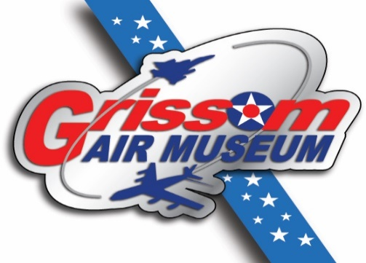
Hoosier Hustler Homecoming
Grissom Air Force Base Museum

May 19-21, 2017
Reunion registration

Name: ______________________________________________________________

Address: ______________________________________________________________

Email: ______________________________________________________________

Telephone:______________________________________________________________

Military affiliation:______________________________________________________

Military rank:____________________________________________________________

Your guests:_____________________________________________________________

Registration fee is $75.00 per person. Please return this form along with your check before April 19, 2017 to:
Grissom Air Museum Hustler
1000 Hoosier Boulevard
Peru, IN 46970

